

Motivators Report Debrief Guide
For Certified Practitioners
VS3_06.20


In partnership with
BehavioralResourceGroup.com
leaders in people intelligence
Table of Contents

Getting Started 3
Motivators Assessment Intro 3

Debriefing the Report
Pages 2-3: Table of Contents, About This Report 4
What are Motivators? 4
Page 3: Seven Dimension of Motivation & Primary Descriptor 5
Importance & Impact 6-7
Risk Areas 7
Page 4: A Closer Look at the Seven Dimensions 8
Page 5: Summary of Your Motivation 8-9
Page 6: Details of your Motivation 9
Page 7: Word Matrix 10
Pages 8-14: Individual Motivators Pages 11
Page 15: Adaptability & Coaching 12
Application 12

Getting Started
Prior to Debrief
- Review the Motivators Report and organize your thoughts to debrief the individual.
- Consider what insights to draw special attention to as you work through the report, tying assessment results to client’s life to provide coaching opportunities.
- Have a copy of the report for you and the client.
- Encourage the client to take notes.
- Offer opportunity for follow up, if applicable.

*NOTE: A debrief is most effective when the individual already has established goals and you can highlight how his/her report content can help or hinder his/her progress. However, this may be unknown to you at this point; therefore, use this debrief as an opportunity to find out what is important to the respondent to ensure time is well spent.

MOTIVATORS ASSESSMENT
This Motivation assessment is unique to the marketplace in that it examines seven unique aspects of motivation. Most similar instruments only examine six dimensions of motivation by combining the Individualistic and Power into one dimension. It also contains the most contemporary list of statements to make choices more relevant to an individual’s life today, which helps ensure the most accurate results possible.

This self-assessment report provides an understanding the motivators and how to maximize performance by achieving stronger alignment between our motivators, our choices, and our actions.
REMINDERS:
- It is not a test. You cannot pass or fail.
- There are no good or bad results and there are strengths and challenges that exist for all different motivations.
- The profile is a measure of your perception. Responding to or taking the profile is a quick, easy way of gathering information about your motivational drives, passions, and attitudes.

DEBRIEFING THE MOTIVATORS REPORT
The easiest way to debrief the report is to follow the layout of the report and work through the report from front to back cover. The layout and design of the report have been carefully crafted to support you in providing the best interpretation possible. Each page describes the type of information it contains as well as how it is useful. In doing so, there are a few things you should look for in each section.

Pages 2 – 3: Table of Contents, About This Report, Seven Dimensions of Motivation
These are static educational pages that don’t change from report to report based on the respondent’s scores.

Key Objectives:
- Summarize the background of the assessment and the Motivational Index
- Introduce the seven dimensions and define them

What are Motivators?
- Motivators will help you understand your motivations and drivers, providing a clear course on how to maximize your performance by achieving better alignment and passion for what you do.
- Motivators provides insight into what we want and what we believe to be true, most important, or fundamental based on our formative years and our learning experiences.
- What we believe influences how we behave so the motivators can help us understand why we do what we do.
- The Motivators filter and guide decisions specifically toward results that will reflect them; they combine uniquely for each person to influence individual priorities and decision-making
As we look through the pages of your report, keep in mind that this is a self-assessment revealing how you see yourself and what is most important to you right now. We will make some connections and look at your drivers to see what influences your behavior according to your own perceptions.

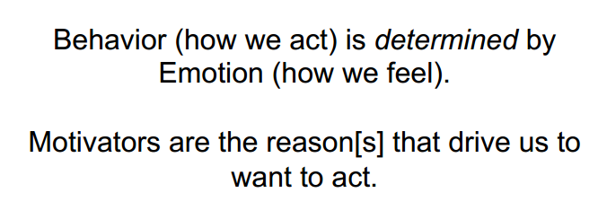

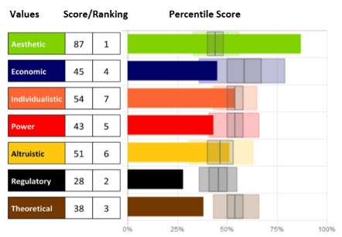
The Seven Dimensions of Motivation
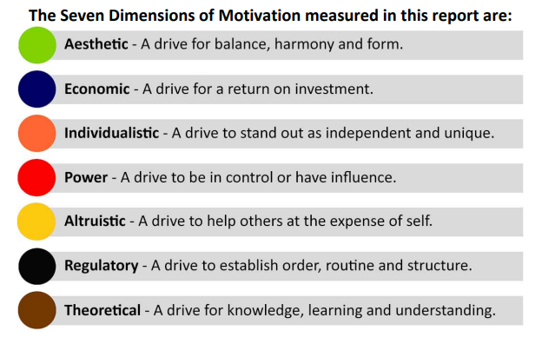

While it’s important to explore each motivator and what they mean, it is critical to remember that they cannot be separated. The motivators all influence our mindset and actions. They can only be distinguished to bring clarity to our individual perspectives.
To further assist our ability to identify and recall each dimension - a primary descriptor:

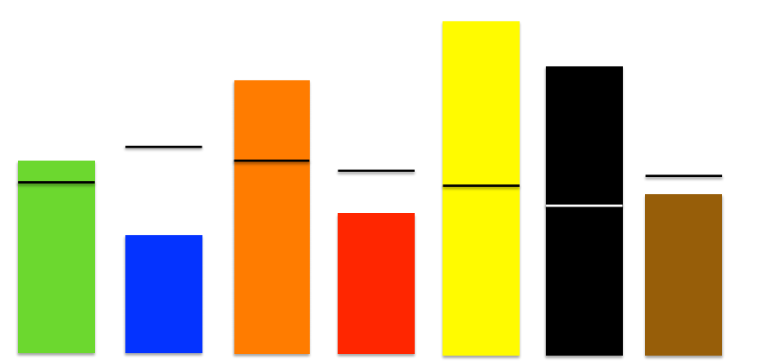
Competitive
Investigative

Alternative
Unique

Controlling

Empathetic

Regulated

*More information on each dimension can be found in the Trainer Materials

IMPORTANCE & IMPACT
Both of these concepts are incredibly important in Motivators. While connected, there are different concepts to consider when reviewing the Motivators.
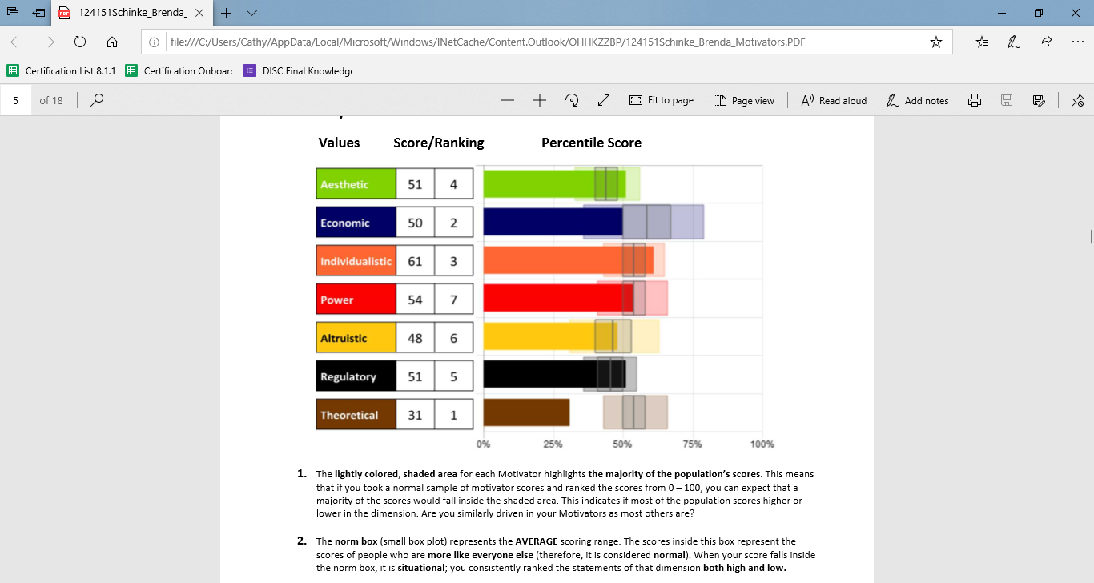

IMPORTANCE is determined by the score and comes in two parts – it explains IF I value the dimension and HOW I value it.

IF I value it:
- A High Score means that the expression of this Motivator is very important to me.
Example: If I am High Economic – getting a return on my investment is VERY Important.
- A LOW Score means that this Motivators is not important to me.
Example: If I am Low Economic, a return on my investment is NOT important to me.

How I value it:
My score (whether high or low) reveals a descriptor of HOW I value the dimension. (We’ll see these later on the word sketch).
- A High ECO score shows Competitive. This is HOW I interact with this Motivator or the “thing” that drives me.
- A Low ECO score shows Satisfied. This is HOW I interact with this Motivator or the “thing” that drives me.
- If I am driven by competition, then everything becomes an opportunity for me to fight for the win. If I am satisfied, I won’t fight for the win, but rather take what is presented to me as it comes and make the best of it.

IMPACT is how it influences my decisions and actions and is determined by distance from perfect center (or 50%) and is shown in the ranking. When exploring impact there are few things to know as well:
  - Impact is determined by how far your score is away from 50% - the balanced center between high and low. The further the score from 50%, the more influence those scores will have on your decisions. Scores that fall within the Average will have less impact because they are without passion, where scores that are higher or lower have more passion for or away from. Those in the middle could go either way, depending on the situation.

While Impact tells us how that Motivator will affect our decisions and actions, it’s helpful to remember some people are driven to be LIKE others, and some are driven to be DIFFERENT.
  - If 7 out of 10 people are all doing things the same way, the only person who will be noticed (and also feel out of place) will be the outlier, doing things in a way others haven’t.
  - Because all people are looking to balance an individual existence with a shared/community existence, being like the population can have a great deal of impact on how we choose to behave. If we don’t want to stand out, we may choose what would make us seem alike, rather than stand out.

We’ll talk more about these concepts again when we look at report scoring but remember these are crucial to understanding how and why our Motivators drive us.

Remember:
- Whether scores are high or low, the motivators with the furthest distance above or below 50% (above or below “perfect balance” in the center) will be the highest influencers leading to the greatest impact on the decisions being made.
- Both low and high scores can have an influence on the choices we make. Average scores (in the mid-range noted by the small box plot) create a normal degree of influence which is typically not noticeable.

Risk Areas

Very Low Low Average High Very High
*Teens and Below *Above 85

The very high and very low are "risk” zones. These are areas outside of what most of the population will understand. If you score in a risk area, that means you have a strong need in that area.
- For example, if you are high AES, you have a strong need, much more than a want, to be alternative and to create balance and harmony in your world.
- If you are low AES, you have a strong need, much more than a want, to be practical.
There is a difference - I can WANT to be a leader or I can NEED to be a leader; each will affect my choices and behaviors.

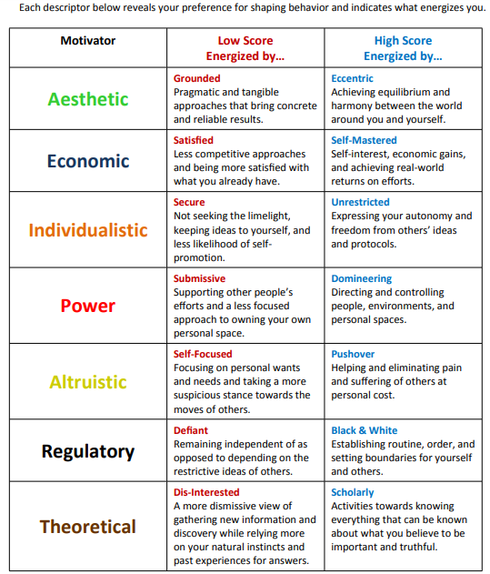
Page 4: A Closer Look at the Seven Dimension Scores

Each of the Motivators is presented with a descriptive word and statement set for both Low and High scores to help the individual understand more details about each Motivator.
Notice the “Energized by” at the top of the Low and High Score columns. This description tells you the drivers associated with this Motivation.

By understanding more about where you fit into this page based on your own score, AND where others may fall on the scale from high to low, you can work to create greater understanding and connection with others who may have different drivers than you do.

Page 5: Summary of Your Motivation
The graph on this page is unique to each person and reflects their scores in each of the seven dimensions.

Key Objectives:
- Review individual scores for each dimension
- Identify the most influential dimensions

- The solid bar & number: Your score in each dimension shown in a bar graph and shows Importance of the dimension
- The shaded area: Indicates where 50% of the population scores in each dimension

- The box plot: Shows the range that makes up an Average score – this is the majority of the people that fall within the 50% shaded area
- The norm line: Shows the MEDIAN score for each dimension
- Ranking: Reveals which score as most impactful to your decisions (true ranking)

Using the information in the graphs, discuss what each Motivator means and the importance and impact individually. In a few minutes, we’ll look at them in combination with one another.

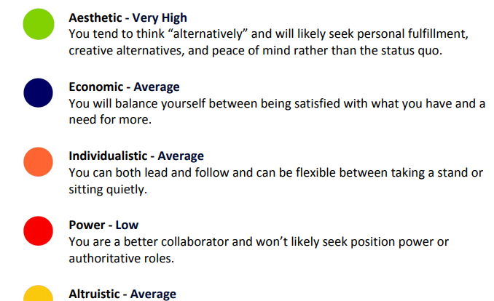

Page 6 - Details of Motivation
This page provides a score range and detailed statement set for each Motivators to help the individual understand how each Motivator shows up for them. It is intended to give a single point of reference for the individual Motivator.

Page 7 – Motivator Word Matrix
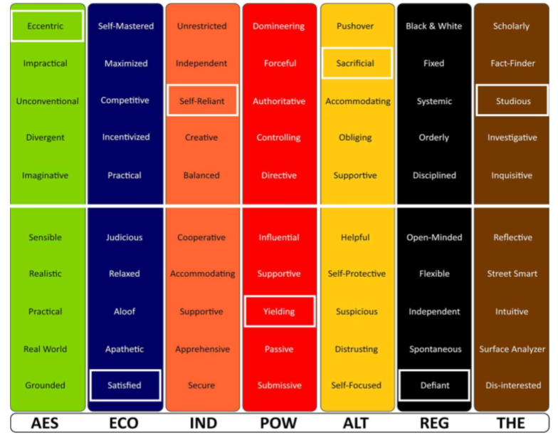

* The white line indicates 50%, perfect balance in these areas. Moving further from that line (high or low) indicates which areas are the more influential.
In the report, the highlighted words help to create a picture of the motivation drivers of this individual, collectively. With these descriptors, you can also see patterns in descriptors, either where there is support, or where there may be areas of tension of conflict.

Questions to ask:
- Which Motivators are most important? Which Motivators are least important?
- Looking at each highlighted word, what do you see that is interesting in the descriptors?
- Are there areas that create patterns or tensions?
- What will have the greatest influence on the decisions?
- How will these impact decisions and actions?

It also may be helpful to explore a bit how these “core values” are expressed in behavior. Are they aligned, or is there something unable to be expressed or satisfied?

Page 8-14 – Individual Motivator Pages

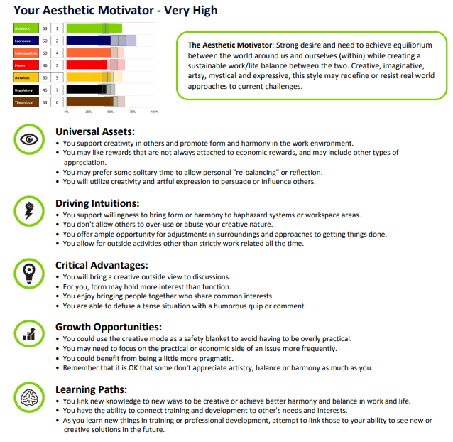
Each page contains five categories for one of the seven dimensions.

Key Objectives:
- Identify the key elements of each Dimension
- Determine applicability of each bullet point to individual
- Examine how well the point is satisfied or leveraged

The five categories are:
- Universal Assets – typical characteristics or preferences associated with this dimension
- Driving Intuitions- things to keep in mind to achieve optimal drive
- Critical Advantages – strengths associated with this dimension
- Growth Opportunities – ideas that might benefit you through self-awareness and authenticity
- Learning Paths – specific characteristics that affect gathering and sharing of knowledge or information

It is recommended starting with the overview or road map for each page.
Begin with defining the Dimension as noted at the top. Then, discuss bullet points that resonate or cause concern or questions. Determine how applicable each point is, and then discuss how it shows up in real life for them.

It’s often most helpful to focus on the most impactful or highest-ranking Motivators first. Alternatively, if there are patterns of support that strengthen a value, these pages would be a great place to focus. While it is recommended that all pages be reviewed, you may decide to do a little at a time as not to overwhelm the learner.

Adaptability:
Overview of Individual Motivator Pattern & Coaching Questions
Page 15 offers some Adaptability questions to continue to explore each Motivator. These can be helpful to build more self-awareness, or to interact with others to reveal their motivations. Sometimes, when we can’t behave in alignment with our core values, they aren’t as easy to see. These questions can help you identify what is important.

Use open-ended and purposeful follow-up questions to uncover opportunities and reveal areas support is needed. Ask relevant questions and discuss:

- What are the motivators that are furthest from the norm score? What do those motivators indicate?
- Are there any conflicting motivators or supporting motivators? What do those motivators indicate?
- What are the primary drivers for this person? How do those drivers show up for them? What behaviors do you see that link to those drivers?
- What awareness do they have about their scores? Are those scores accurate and reflective of their mindset?
- How do those motivators and that mindset influence their choices and behaviors?
- Are their behaviors reflecting their wants accurately? If not, why not and should something be done to align them closer?

Application
Page 16-18 – Guidelines and Reflection
This page is designed to further the discussion and create a connection between the Motivators and real life.

- Evaluate area of desire for adapting and adjusting to be more effective.
- Suggest improvement ideas and build a clear action plan to address any challenges or struggles. Use the “Continual Improvement Insights” section for the appropriate motivators for some coaching ideas.
- Discuss how they will be accountable (self-accountability, accountability partner, coach).

